Python code to exe convert
- Install python and pyinstaller. User can check python and pyinstaller version through cmd.
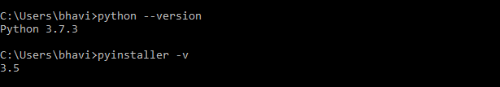

- Remove app.spec and ib.log file from your project if these file exists in your project. In below image, You can see my project structure....
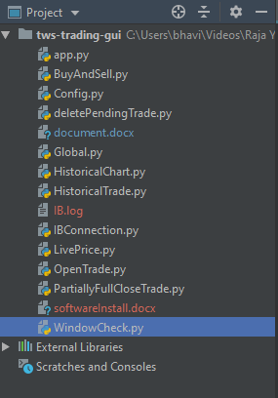

- last step, execute ‘ pyinstaller –onefile app.py ‘ command in your project directory. Here ‘ app.py ‘ is a main file.
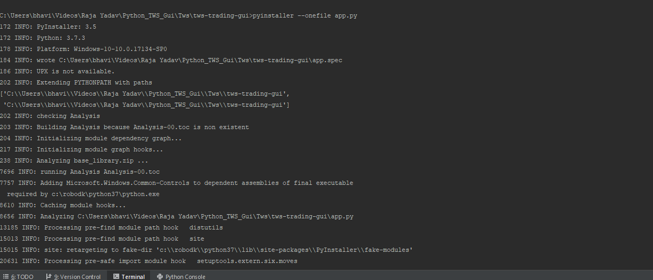

Successfully complete...
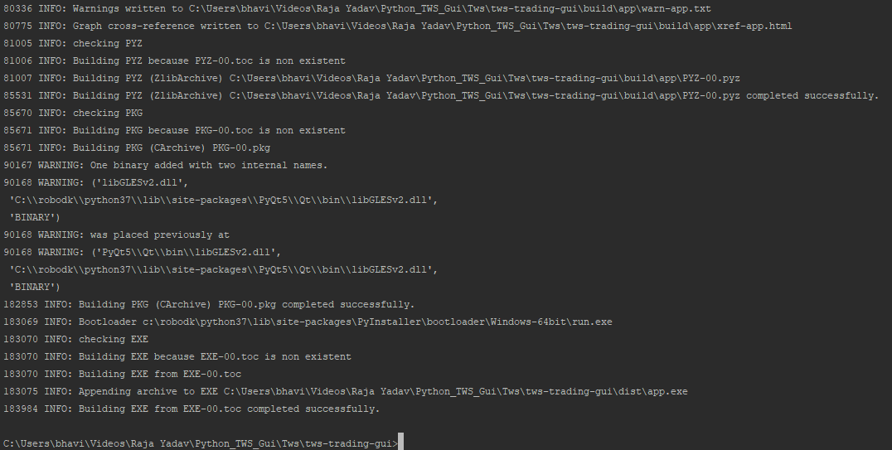

- now you can see dist folder in your project directory. In dist folder you can find exe file.
